

**2017 Year 12 PHYSICS ATAR**

**Semester 1**

**Task 6: Test 1**

**TASK TYPE: Test**

**CONTENT: Vectors, Forces and Projectile Motion – 5%**

|  |  |  |
| --- | --- | --- |
|  | **Possible Marks** | **Your Mark** |
| **Total** | **45** |  |
| **Percentage** | **100%** |  |

**Student Name: ____________________________________**

**Date: ____________________________________**

**Teacher: J. Wijaya**

**Instruction:**

1. **Answer all questions.**
2. **All numeric answers are to be corrected to three significant figures unless specified.**
3. The air rifles for the “duck shooting” at a fun fair fire the pellets at 30.0 ms-1. A girl fires the rifle at a duck 5.00 m away. She aims horizontally (at point (0,0), origin) at the “duck” which moves sideways at 0.500 ms-1. Ignore air resistance.
   1. 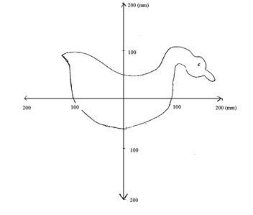How long does the pellet take to reach the duck? [2]

**Answer: ________________________**

* 1. How far ***below origin*** will the girl’s pellet hit? Show your calculations. [4]

**Answer: ________________________**

* 1. Calculate the horizontal distance from the origin that this girl’s will hit. Write the answer in the space provided. [3]

**Answer: ________________________ Left / Right (circle the correct answer) to the origin.**

1. Marvin takes 15.0 minutes to paddle his canoe 500 m (West to the opposite of the bank) in still water.
   1. Calculate Marvin’s velocity.

[2]

**Answer: ______________________________ Direction: ___________________________**

After 15.0 minutes, Marvin returns to the opposite direction with the same speed. This time, due to the strong wind, the river flows at 3.00 m s-1 to the south.

* 1. Draw a vector diagram to show the motion of going back, showing the net velocity. Give appropriate labels.

[2]

* 1. Calculate the net velocity.

[3]

**Answer: ______________________________ Direction: ___________________________**

1. A car enters an intersection at 20.0 m s-1 to the North where it collides with a truck. The impact rotates the car 90.0° clockwise and gives it a speed of 15.0 m s-1.
   1. Use the space below, using appropriate vectors to show the change of velocity of the car.

[2]

* 1. Calculate the change of velocity. Include direction.

[4]

**Answer: ______________________________ Direction: ___________________________**

1. The diagram below shows a ball is rolling down a hill and accelerates. Ignore friction.
   1. On the diagram **below,** with the reference to the ball, show all forces including the net force.

[3]

* 1. If the mass of the ball is 60.0 kg and the incline is 15.0o, calculate magnitude the net force acting on the ball.

[3]

**Answer: ______________________________**

* 1. Explain if this motion relates to the Newton’s first law of motion.

[2]

1. A cannon is projected at 37.0o at 65.0 m s-1 at the 125 m cliff. On the diagram below, it shows the position of the cannon at a certain time.

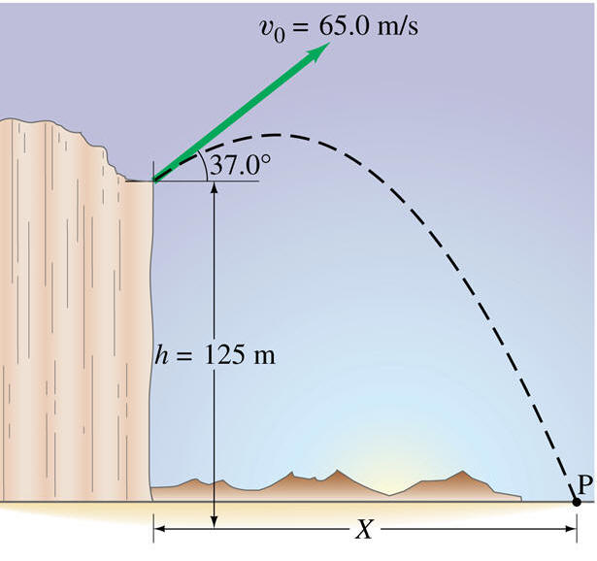

* 1. On the diagram,

[2]

* + 1. Use letter **W** to show the net force of the cannon.
    2. Use letter **V** to show the instantaneous velocity of the cannon.
  1. Use the information to calculate the horizontal distance that the cannon can reach. [6]

**Answer: ______________________________**

* 1. A skateboarder at a skate park rides along the path shown in the diagram below. If the speed of the skateboarder at point A is 1.30 m s-1, what is her speed at point B? Assume that friction is negligible.

[4]

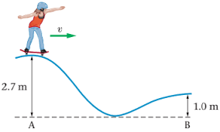

[Reference <https://www.physicsforums.com/threads/find-final-speed-using-mechanical-energy->formula.893415]

**Answer: ______________________________**

* 1. If the skater rides from the top of the path (with the height of h metres) from rest, prove that the speed at the bottom of the path is:

[3]

$$v_{bottom}=\sqrt{2gh}$$

**End of the Test**